Cairo University Faculty of Computers and Artificial Intelligence

Computer Science Department – Software Engineering Undergrad Program

# SLB 361: Software Engineering Tools Lab, MIDTERM EXAMINATION

Fall 2020 – CLOSED Book Exam –Total marks: 20 – Duration: 60 mins

**This exam comes in five pages**

STUDENT NAME

STUDENT ID #

**Question 1 [7 marks]**

**1- ………….../sndconfig file is responsible for Configuration of the sound card and sound events.**

a- home

b- user/bin

**c- etc**

d- root

**2- Which of the following are benefits of open source software for the user?**

**a. Code can survive the loss of the original developer or distributor.**

b. Sensitive portions of code are protected and only available to the original developer.

c. Come with extensive support.

d. Code remains open as long as it is in a public repository but the license may change when included with closed source software.

**3- Which statement is not a benefit of Linux?**

**a. Linux is developed entirely by volunteers making it a low cost operating system.**

b. Linux is modular and can be configured as a full graphical desktop or a small appliance.

c. You can download the source code and change it any way you like.

d. Linux includes a powerful and scriptable command-line interface, enabling easier automation and provisioning.

**4- Which term describes the part of the command line that adjusts the behavior of a command?**

a. Argument

b. Command

**c. Option**

d. Prompt

**5- Which term describes one of multiple logical consoles that can each support an independent login session?**

a. Physical Console

**b. Virtual Console**

c. Shell

d. Terminal

**6. Which Bash shortcut or command separates commands on the same line?**

a. Pressing Tab

b. history

**c. ;**

d. !string

e. Pressing Esc+.

**7. Which Bash shortcut or command displays the list of previous commands?**

a. Pressing Tab

b. !string

c. !number

**d. history**

e. Pressing Esc+.

**8. Which directory contains installed software programs and libraries?**

a. /etc

b. /lib

**c. /usr**

d. /var

**9. Which pattern will match only filenames that contain a number?**

a. *#*

**b. *[[:digit:]]\***

c. *[digit]*

d. [0-9]

**10. Which answer sends output and errors to the same file ensuring existing file content is**

**preserved?**

a. >file 2>file2

b. &>file

**c. >>file 2>&1**

d. >>file 1>&1

**11- Using “No Login Shell” helps in:**

a. Performance

b. Easy login

**c. Security**

d. Administration

**Use the following information to solve the next questions**

• User consultant1 is in groups consultant1 and database1

• User operator1 is in groups operator1 and database1

• User contractor1 is in groups contractor1 and contractor3

• User operator2 is in groups operator2 and contractor3

The current directory (.) contains four files with the following permissions information:

drwxrwxr-x. operator1 database1 .

-rw-rw-r--. consultant1 consultant1 lfile1

-rw-r--rw-. consultant1 database1 lfile2

-rw-rw-r--. operator1 database1 rfile1

-rw-r-----. operator1 database1 rfile2

**12. Which file can be modified by the contractor1 user?**

a. lfile1

**b. lfile2**

c. rfile1

d. rfile2

**13. Which files can be deleted by the operator1 user?**

a. rfile1

b. rfile2

**c. All of the above.**

d. None of the above.

**14- Which of the following commands will allow user ‘operator1’ to edit and read ‘lfile2’**

a- chmod u=rw lfile2

b- chmod g=w lfile2

c- chmod 757 lfile2

**d- chmod g+w lfile2**

**Question 2 [13 marks]: Apply the following actions using the RedHat Linux commands**

1- Add a new user called **‘miduser’** and set his password to **‘rh-2020’**.

sudo useradd miduser   ;  passwd miduser   **rh-2020**

2- Print the current user information to the screen and append it to **‘userinfo.txt’** file using one command. Then you should check that it is saved in the file.

id | **tee** **-a** userinfo.txt

cat userinfo.txt

3- Grant superuser access to the **‘miduser’** user. (Hint: you can edit /etc/sudoers file using visudo command by opening it in vim editor)

visudo

Press “i” : edit  “/etc/sudoers” using vim insert mode   
Add this line miduser All=(All)   All

Press “ESC”

then :wq to save and close

4- Create a new group called **‘midtermgroup’** then

* Add it as a secondary group to the root user
* Add it as a primary group to ‘**miduser’**

groupadd midtermgroup

usermod **-aG** midtermgroup **root**

usermod **-g** midtermgroup **miduser**

5- Using the root user to create a new directory **‘/home/miduser/mid term/SE lab’** in **one** command then:

* Change the owner group of this directory to be the **‘midtermgroup’** group
* Set the directory access permission to allow:
  + The owner user: read, write, and execute
  + The owner group: read and write
  + The others: read
* List the directory information to make sure that the access permissions are applied

* mkdir **-p** **‘**/home/miduser/mid term/SE lab**’**

* **chown** :midtermgroup ‘/home/miduser/mid term/SE lab’

* **chmod 764** ‘/home/miduser/mid term/SE lab’

* ls **-ld** ‘/home/miduser/mid term/SE lab’

6- Add the **sgid** permission to **‘SE lab’** directory

**chmod g+s**  ‘/home/miduser/mid term/SE lab’

7- Prevent users from removing files that they don’t own.

**chmod o+t** ‘/home/miduser/mid term/SE lab’

8- Create the following file structure in **one command** using expansions.

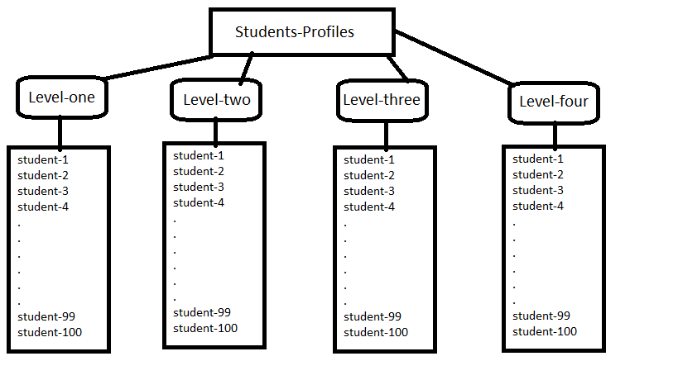

The **Students-Profiles** directory contains 4 directories **Level-one, Level-two, Level-three, Level-four**. Inside each directory there are 100 directories named as **student-1** to **student-100**

mkdir -p Students-Profiles/Level-{one,two,three,four}/student-{1..100}

9- Change your current directory to be at the “**Level-one”** directory. Then list its contents in detail to see their access permissions and display the output page by page

cd Level-one

ls -l | more (less)

10- Remove the write access from group permissions for any file or directory that ends with 0   
(i.e. student-10, student-20) in one command directory then list all the directory contents in details to make sure that permissions are updated successfully

chmod g-w  *0

11- Go to the parent directory of your current location (don’t use absolute path) and print current directory (it should be ‘**Students-Profiles’**) then remove the ‘**Level-four’** directory

cd ..

rm -r Level-four

12- Print the first 20 command you have executed in the terminal to a file named as **‘first20commands.txt’** and if any error happened redirect it to the **‘errorlog.txt’** file

history | head -20 > first20commands.txt  2 > errorlog.txt